# Final Laboratory Activity 2

Name: Abenes, Enrico O.

Subject Code & Schedule: CC1-INTL1, MT 1:30 pm – 5:20 pm Course and Year: BSIT – 1st Year

## TITLE: One Dimensional Array LEARNING OBJECTIVES:

At the end of this activity, the students should be able to:

1. Declare a one-dimensional array in Java.
2. Initialize and reference elements in a one-dimensional array.
3. Perform basic operations available for a one-dimensional array.
4. Create a complete Java program that simulates the application of a one- dimensional array.

## INSTRUCTIONS:

1. Make sure you have your own individual account.
2. Always keep your account secret to others to avoid unauthorized access to your files.
3. Always save your work and log-off when not using the computer.
4. By now you should have been familiarized using your text editor.
5. By now you should know how to create, save, compile, execute, and debug programs in Java.
6. Use the skills and learning obtained in Prelim Activity1 to Midterm Activity

4 in order for you to successfully finish the learning objectives of this module.

## DURATION: Two to Three Meetings HANDS-ON:

1. Log-on using your own individual account. Use your own **username** and

## password.

1. Open your text editor.
2. Write your next Java program:
   1. Write your next program by copying the source code shown below to your text editor.

/* Programmed by: <write your name here> Program title: List.java

Program Date: <write the date today here> */

import java.io.*; public class List{

public static void main(String[] args){ int list[] = new int[10];

int i, num = 0; String input = “ “;

BufferedReader in = new BufferedReader(new

InputStreamReader(System.in));

for(i = 0; i < 10; i++){ list[i] = 0;

}

for(i = 0; i < 10; i++){ System.out.print(“Input value for list[“ + i +

“] = “);

try{

input = in.readLine();

}catch(IOException e){}

num = Integer.parseInt(input); list[i] = num;

}

for(i = 0; i < 10; i++){

System.out.println(“list[“ + i + “] = “ +list[i]);

}

}

}

* 1. Save the program as **List.java** then compile your program until no errors and warnings are reported.
  2. Run your program.
  3. Simulate and write what will be displayed on the screen.

Input value for list [0) = 3

Input value for list [1) = 5

Input value for list [2) = 5

Input value for list [3) = 7

Input value for list [4) = 5

Input value for list [5) = 2

Input value for list [6) = 6

Input value for list [7) = 9

Input value for list [8) = 6

Input value for list [9) = 7

* 1. What do you think is the purpose of the first for-loop?

list [0] = 3

list [1] = 5

list [2] = 5

list [3] = 7

list [4] = 5

list [5] = 2

list [6] = 6

list [7] = 9

list [8] = 6

list [9] = 7

Before the user enters any specific values, the **first for-loop** initializes the array elements to 0,

giving each element a starting point value.

* 1. What do you think is the purpose of the second for-loop?

The user can input values for each element of the list array using the **second for-loop**, giving the application user-specific data to work with afterwards.

* 1. What do you think is the purpose of the third for-loop?

The **third for-loop** is in charge of reporting the list array's values to the console so you can check the values the user supplied and make sure they were properly stored in the array.

* 1. How many elements can your list contain? Ten (10) elements
  2. What index value is the first element located? Index value zero (0)
  3. Given the <size> of the list, at what index is the last element located? Index value nine (9)

1. Create a new program and save it as **List2.java**. Thereafter, create 3 lists and name is as **list1**, **list2**, and **list3**, having 10 elements each. The user should input 10 integer values for **list1** and 10 integer values for **list2**. Your program should add the contents of **list1** and **list2** then store the sum to **list3**. Your program should display horizontally the values of **list1**, **list2**, and **list3**. Use loops.

Example output:

|  |  |  |  |  |  |  |  |  |
| --- | --- | --- | --- | --- | --- | --- | --- | --- |
| List1 : 1 | 3 | 2 | 5 | 7 8 | 5 | 6 | 9 | 4 |
| List2 : 2 | 1 | 4 | 3 | 2 1 | 4 | 2 | 0 | 2 |
| List3 : 3 | 4 | 6 | 8 | 9 9 | 9 | 8 | 9 | 6 |

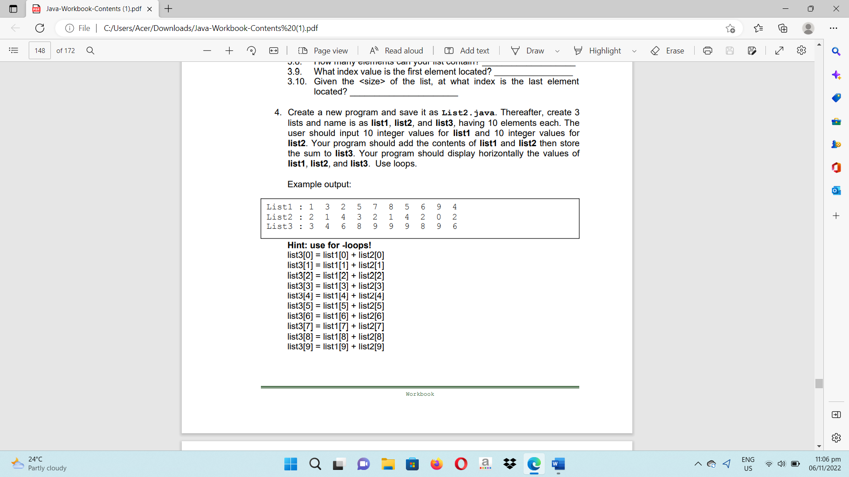

* 1. Write your complete Java program here:

/* Programmed by: Abenes, Enrico O.

Program Title: List2.java

Program Date: July 11, 2023*/

package intl.cc1;

import java.io.BufferedReader;

import java.io.InputStreamReader;

import java.io.IOException;

public class List2 {

public static void main(String[] args) {

String input = " ";

int[] list1 = new int[10];

int[] list2 = new int[10];

int[] list3 = new int[10];

BufferedReader basa = new BufferedReader(new InputStreamReader(System.in));

try {

System.out.println("Enter Ten(10) Integer Values for List1");

for (int i = 0; i < 10; i++) {

System.out.print("Input value for list1[" + i + "] = ");

input = basa.readLine();

list1[i] = Integer.parseInt(input);

}

System.out.println(" ");

System.out.println("Enter Ten(10) Integer Values for List2");

for (int i = 0; i < 10; i++) {

System.out.print("Input value for list2[" + i + "] = ");

input = basa.readLine();

list2[i] = Integer.parseInt(input);

}

System.out.print("List1 : ");

for (int i = 0; i < 10; i++) {

System.out.print(list1[i] + " ");

}

System.out.println();

System.out.print("List2 : ");

for (int i = 0; i < 10; i++) {

System.out.print(list2[i] + " ");

}

System.out.println();

for (int i = 0; i < 10; i++) {

list3[i] = list1[i] + list2[i];

}

System.out.print("List3 : ");

for (int i = 0; i < 10; i++) {

System.out.print(list3[i] + " ");

}

System.out.println();

} catch (IOException e) {

System.out.println("Error!");

}

}

System.out.print("List1 : ");

for (int i = 0; i < 10; i++) {

System.out.print(list1[i] + " ");

}

System.out.println();

System.out.print("List2 : ");

for (int i = 0; i < 10; i++) {

System.out.print(list2[i] + " ");

}

System.out.println();

for (int i = 0; i < 10; i++) {

list3[i] = list1[i] + list2[i];

}

System.out.print("List3 : ");

for (int i = 0; i < 10; i++) {

System.out.print(list3[i] + " ");

}

System.out.println();

} catch (IOException e) {

System.out.println("Error!");

}

}

}

* 1. Save then compile your program until no errors and warnings are reported.
  2. Run your program.
  3. Simulate and write what will be displayed on the screen.

Enter Ten(10) Integer Values for List1

Input value for list1[0] = 1

Input value for list1[1] = 3

Input value for list1[2] = 4

Input value for list1[3] = 2

Input value for list1[4] = 1

Input value for list1[5] = 5

Input value for list1[6] = 4

Input value for list1[7] = 2

Input value for list1[8] = 4

Input value for list1[9] = 2

Enter Ten(10) Integer Values for List2

Input value for list2[0] = 5

Input value for list2[1] = 3

Input value for list2[2] = 2

Input value for list2[3] = 5

Input value for list2[4] = 1

Input value for list2[5] = 4

Input value for list2[6] = 3

Input value for list2[7] = 5

Input value for list2[8] = 2

Input value for list2[9] = 1

List1 : 1 3 4 2 1 5 4 2 4 2

List2 : 5 3 2 5 1 4 3 5 2 1

List3 : 6 6 6 7 2 9 7 7 6 3

List1 : 1 3 4 2 1 5 4 2 4 2

List2 : 5 3 2 5 1 4 3 5 2 1

List3 : 6 6 6 7 2 9 7 7 6 3

1. Revise your **List2.java** program. Thereafter, your program should display the highest value in **list3** and the lowest value in **list3**.
   1. Write the additional codes here:

int mataas = list3[0];

int mababa = list3[0];

for (int i = 1; i < 10; i++) {

if (list3[i] > mataas) {

mataas = list3[i];

}

if (list3[i] < mababa) {

mababa = list3[i];

}

}

System.out.println("Highest value in List3: " + mataas);

System.out.println("Lowest value in List3: " + mababa);

1. Revise your **List2.java** program. Thereafter, your program should allow the user to input an integer value to be searched in **list3**. Your program should display whether the inputted integer value is found in **list3**, how many of it is in **list3**, and what are their locations in **list3**?

Example output:

Input value to search in List3: 9 The value 9 is in List3!

There are 4 of it in List3.

Located at: list3[4], list3[5], list3[6], list3[8]

|  |  |  |  |  |  |  |  |  |
| --- | --- | --- | --- | --- | --- | --- | --- | --- |
| List1 : 1 | 3 | 2 | 5 | 7 8 | 5 | 6 | 9 | 4 |
| List2 : 2 | 1 | 4 | 3 | 2 1 | 4 | 2 | 0 | 2 |
| List3 : 3 | 4 | 6 | 8 | 9 9 | 9 | 8 | 9 | 6 |

* 1. Save then compile your program until no errors and warnings are reported.
  2. Run your program.

Enter Ten(10) Integer Values for List1

Input value for list1[0] = 1

Input value for list1[1] = 4

Input value for list1[2] = 5

Input value for list1[3] = 3

Input value for list1[4] = 2

Input value for list1[5] = 1

Input value for list1[6] = 5

Input value for list1[7] = 4

Input value for list1[8] = 5

Input value for list1[9] = 3

* 1. Simulate and write what will be displayed on the screen.

Enter Ten(10) Integer Values for List2

Input value for list2[0] = 1

Input value for list2[1] = 4

Input value for list2[2] = 2

Input value for list2[3] = 5

Input value for list2[4] = 4

Input value for list2[5] = 2

Input value for list2[6] = 1

Input value for list2[7] = 4

Input value for list2[8] = 3

Input value for list2[9] = 4

List1 : 1 4 5 3 2 1 5 4 5 3

List2 : 1 4 2 5 4 2 1 4 3 4

List3 : 2 8 7 8 6 3 6 8 8 7

Input value to search in List3: 8

The value 8 is in List3!

There are 4 of it in List 3.

Located at: list3[1]. list3[3]. list3[7]. list3[8]

* 1. Write your complete source code here:

/* Programmed by: Abenes, Enrico O.

Program Title: List2.java

Program Date: July 11, 2023*/

package intl.cc1;

import java.io.BufferedReader;

import java.io.InputStreamReader;

import java.io.IOException;

public class List2 {

public static void main(String[] args) {

String search_input, input;

boolean hanap = false;

int search_value, ctr = 0;

int[] list1 = new int[10];

int[] list2 = new int[10];

int[] list3 = new int[10];

BufferedReader basa = new BufferedReader(new InputStreamReader(System.in));

try {

System.out.println("Enter Ten(10) Integer Values for List1");

for (int i = 0; i < 10; i++) {

System.out.print("Input value for list1[" + i + "] = ");

input = basa.readLine();

list1[i] = Integer.parseInt(input);

}

System.out.println(" ");

System.out.println("Enter Ten(10) Integer Values for List2");

for (int i = 0; i < 10; i++) {

System.out.print("Input value for list2[" + i + "] = ");

input = basa.readLine();

list2[i] = Integer.parseInt(input);

}

System.out.println(" ");

System.out.print("List1 : ");

for (int i = 0; i < 10; i++) {

System.out.print(list1[i] + " ");

}

System.out.println();

System.out.print("List2 : ");

for (int i = 0; i < 10; i++) {

System.out.print(list2[i] + " ");

}

System.out.println();

for (int i = 0; i < 10; i++) {

list3[i] = list1[i] + list2[i];

}

System.out.print("List3 : ");

for (int i = 0; i < 10; i++) {

System.out.print(list3[i] + " ");

}

System.out.println();

System.out.println(" ");

System.out.print("Input value to search in List3: ");

search_input = basa.readLine();

search_value = Integer.parseInt(search_input);

StringBuilder lokasyon = new StringBuilder();

System.out.println(" ");

for (int i = 0; i < 10; i++) {

if (list3[i] == search_value) {

if (!hanap) {

System.out.println("The value " + search_value + " is in List3!");

hanap = true;

}

ctr++;

lokasyon.append("list3[").append(i).append("]. ");

}

}

if (hanap) {

System.out.println("There are " + ctr + " of it in List 3.");

System.out.println("Located at: " + lokasyon.substring(0, lokasyon.length() - 2));

} else {

System.out.println("The value " + search_value + " is not found in List3");

}

} catch (IOException e) {

System.out.println("Error!");

}

}

}

1. Create a new program and save it as **BubbleSort.java**. Thereafter, the user will be asked to input the size of the list, input values to the list, sort the list in ascending order, and display the sorted list in a horizontal manner.
   1. Write your complete source code here:

/* Programmed by: Abenes, Enrico O.

Program Title: BubbleSort.java

Program Date: July 11, 2023*/

package intl.cc1;

import java.io.BufferedReader;

import java.io.InputStreamReader;

import java.io.IOException;

public class BubbleSort {

public static void main(String args[]) {

BufferedReader basa = new BufferedReader(new InputStreamReader(System.in));

try {

System.out.print("Enter the size of list: ");

int laki = Integer.parseInt(basa.readLine());

int[] list = new int[laki];

System.out.println(" ");

System.out.println("Enter the values for the list: ");

for (int i = 0; i < laki; i++) {

System.out.print("Value " + (i+1) + ": ");

list[i] = Integer.parseInt(basa.readLine());

}

for (int i = 0; i < laki - 1; i++) {

for (int j = 0; j < laki - i - 1; j++) {

if (list[j] > list[j + 1]) {

int temp = list[j];

list[j]= list[j + 1];

list[j + 1] = temp;

}

}

}

System.out.println(" ");

System.out.print("Sorted list: ");

for (int i = 0; i < laki; i++) {

System.out.print(list[i] + " ");

}

} catch (IOException e) {

System.out.println("Error!");

} catch (NumberFormatException e) {

System.out.println("Invalid. Please input a number.");

}

}

}

* 1. Save then compile your program until no errors and warnings are reported. Run your program.
  2. Simulate and write what will be displayed on the screen.

Enter the size of list: 13

Enter the values for the list:

Value 1: 23

Value 2: 13

Value 3: 53

Value 4: 32

Value 5: 14

Value 6: 24

Value 7: 42

Value 8: 54

Value 9: 23

Value 10: 12

Value 11: 42

Value 12: 54

Value 13: 17

Sorted list: 12 13 14 17 23 23 24 32 42 42 53 54 54

Rubrics:

|  |  |  |
| --- | --- | --- |
| Code Content | The source code submitted covers all the items specified in the activity and satisfactorily meets all these requirements. It also makes use of the specific features of Java specified in the activity. | 20 pts |
| Code Function | The source code submitted works completely with no errors and provides the correct expected output when run. | 20 pts |
| Code Syntax | The source code submitted has sound logic and follows proper syntax for Java, with no unnecessarily complicated code. | 10 pts |
| **Total** | | **100 pts** |